Ideation Phase
Brainstorm & Idea Prioritization Template
Date | 28 January 2026
Team ID | LTVIP2026TMIDS84448
Project Name | Civil Engineering Insight Studio
Maximum Marks | 4 Marks

Brainstorming ideas is a creative process where a group generates a list of potential solutions, suggestions, or concepts for a specific problem or project voting in brainstorming involves participants selecting and prioritizing their favorite or most promising ideas from the list to determine which ones should be pursued further.
Brainstorming for Civil Engineering Insight Studio:
The ideation phase focused on identifying real-world problems in civil engineering such as inefficient planning, lack of predictive insights, maintenance delays, and limited data visualization. Brainstorming involved civil engineers, academicians, students, and infrastructure planners.
The brainstorming phase focused on identifying major challenges faced in modern civil engineering projects and proposing digital solutions to address them. The team explored ideas related to structural safety analysis, construction analytics, sustainability evaluation, and smart decision-support systems.
The core idea prioritized was the development of an insight-driven platform that transforms raw engineering and project data into actionable intelligence for civil engineers and planners.
Step-1 : Team Gathering, Collaboration and Select the Problem Statement
To initiate the Civil Engineering Insight Studio project, a multidisciplinary team was formed consisting of members with knowledge in civil engineering fundamentals, construction planning, data analysis, and software development. Each team member was assigned a specific role based on their strengths, ensuring effective collaboration and balanced contribution throughout the project lifecycle.
The team conducted multiple brainstorming and discussion sessions to understand the current challenges faced in civil engineering projects, particularly in the areas of structural safety, cost estimation, material selection, sustainability assessment, and project monitoring. Academic references, real-world construction case studies, and industry practices were reviewed to gain a deeper understanding of the gaps in existing systems.
During collaboration meetings, the team identified that many civil engineering projects rely heavily on manual calculations, static reports, and disconnected tools, which often result in design inefficiencies, delayed decision-making, safety risks, and cost overruns. The lack of a unified platform that provides integrated insights across different project parameters was recognized as a major problem.

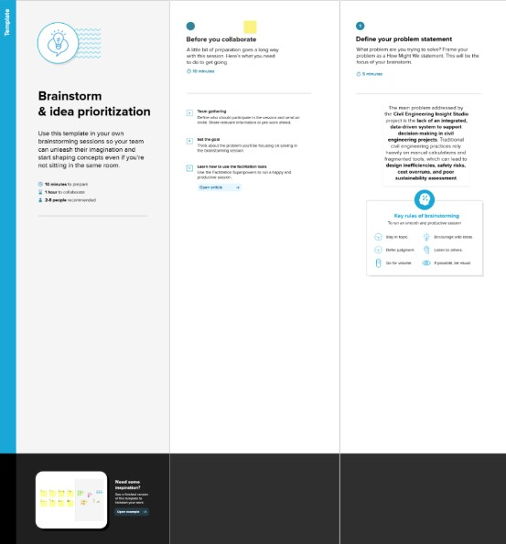

Step-2: Brainstorm, Idea Listing and grouping
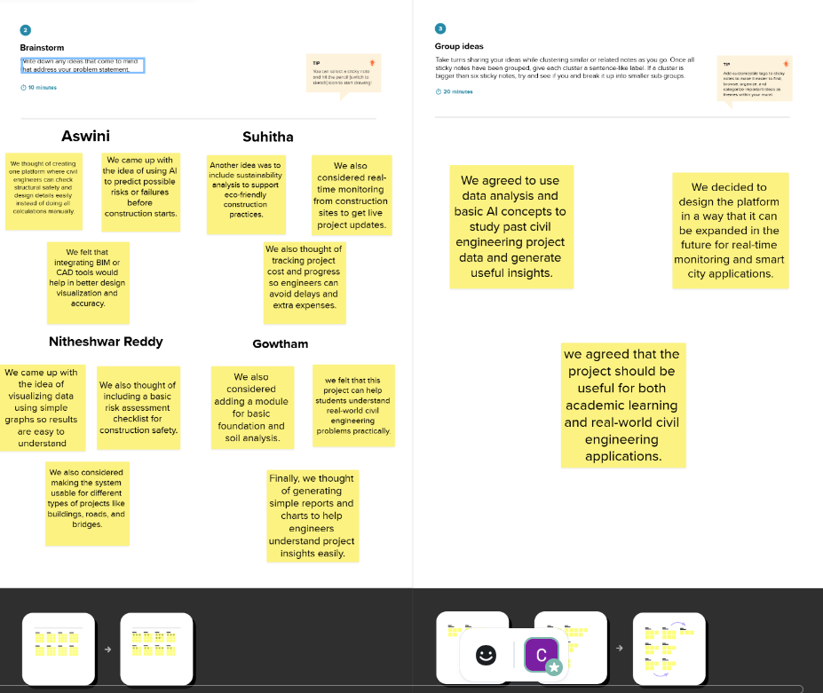

Step-3: Idea Prioritization
Idea prioritization is the process of ranking or assessing ideas based on specific criteria such as feasibility, impact, cost, or strategic importance to determine which ideas should be implemented or pursued first.
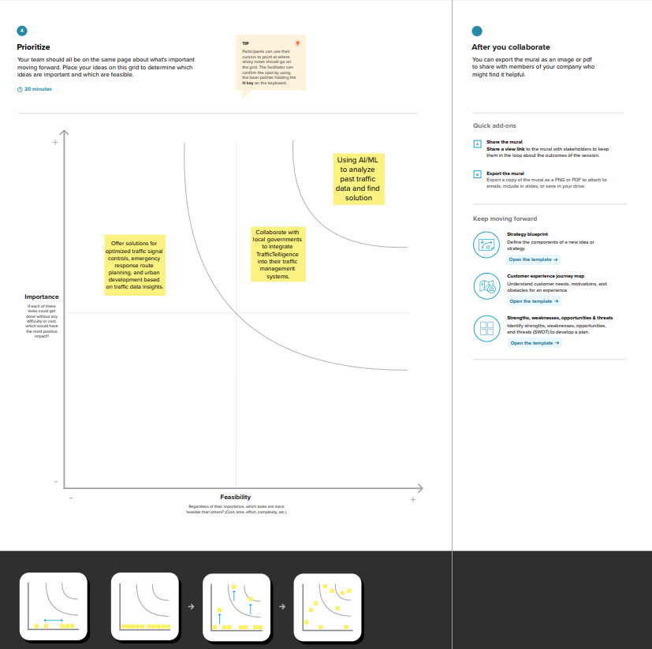

Here, we chose to use AI and data analytics to analyze past civil engineering data and provide better solutions for planning, design, and construction.
The second key idea involves collaborating with government and construction authorities to integrate Civil Engineering Insight Studio into public infrastructure planning, ensuring social impact and practical usability. The next idea focuses on extending the system to support optimized structural design and sustainable urban development through data-driven engineering insights.

